––



CS-255 Project two

Shannon Sims 4/26/2025



# CS 255 System Design Document

## UML Diagrams

### UML Use Case Diagram

### UML Activity Diagrams

### Customer Log in/ Driver Log in

### 

### UML Sequence Diagram

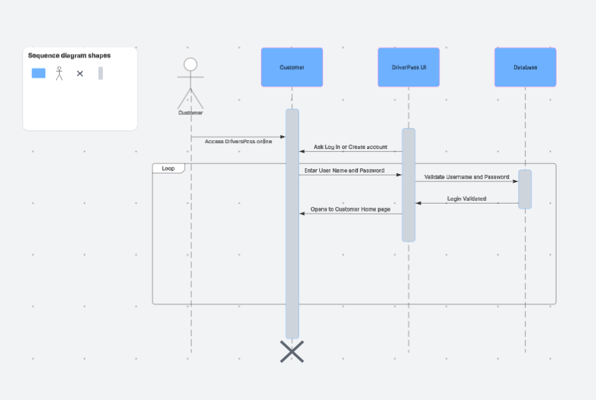

### UML Class Diagram

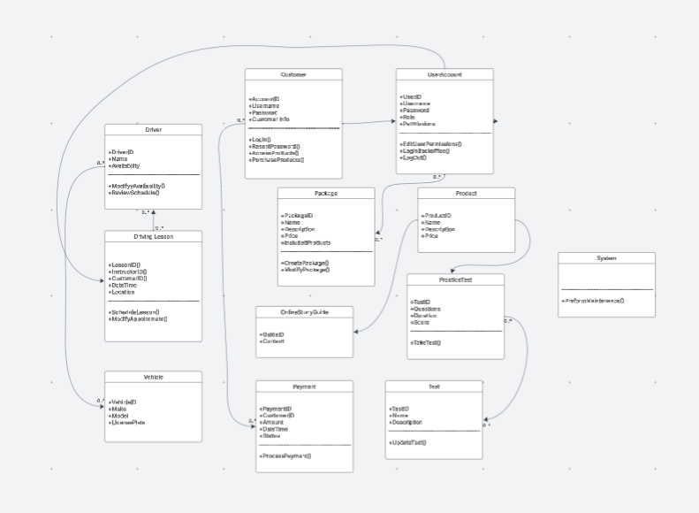

## Technical Requirements

*There are several things to be considered when it comes to technical requirements.*

*The system side requirements will include an operating system that must be robust like Linux. We will need web server software to handle request and serve the application we recommend Apache HTTP server. For application server/runtime environment we would use Java development kit in the application server like jetty.*

*To manage our database we will use a relational database like MySQL. Our network infrastructure needs reliable network connectivity. We should have a firewall for security to protect the server from unauthorized access. We will need security infrastructure like SSL/TLS certificates to encrypt communication.*

*The client side requirements would be a modern web browser such as Google Chrome, safari, or Microsoft Edge. The client will need a stable Internet connection to access the web application. The system can be accessed from various devices like laptop, desktop computers, tablets, in smartphones.*

*We will also need payment gateway integration so online payments can be processed. We will need to create a DMV interface so that the system can interact directly with the DMV.*